|  |  |
| --- | --- |
| 翻译前字数 | 396 |
| 目录 | Unity Manual/Unity Services/Unity Collaborate/Adding teammates to Collaborate |
| 链接 | https://docs.unity3d.com/540/Documentation/Manual/UnityCollaborateAddingTeammates.html |

**Adding teammates to Collaborate**

**将队友到添加协作**

Adding teammates allows everyone to share their work.

添加队友可以让每个人共享他们的工作

Add teammates to Collaborate by opening the **Collab** window and clicking the **People** icon shown at the bottom.

通过打开协作窗口并且通过点击底部显示的人物图标将队友添加到协作中。

People iconPeople icon

人物图标

This opens up the **Members** section (also found within the Services menu). Invite a teammate to be added to the project by entering their email address and clicking **Invite**.

这会打开成员部分（也可以在服务菜单中找到）。通过输入他们的邮箱地址并且点击**邀请**可以添加队友到项目中。

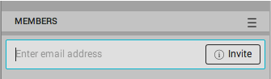

You can also manage teammates and organizations here: <https://id.unity.com/organizations>

您也可以从<https://id.unity.com/organizations> 管理队友和组织